Workbench

Quick Open rewrite

The Quick Open (Ctrl+P) control was using an old version of our tree widget, and in this iteration, it was migrated to use our latest list control, already used in the rest of the VS Code UI. Functionally, you should not be able to tell the difference, as all commands will work as before.

We did take this opportunity to add some features that you might find useful.

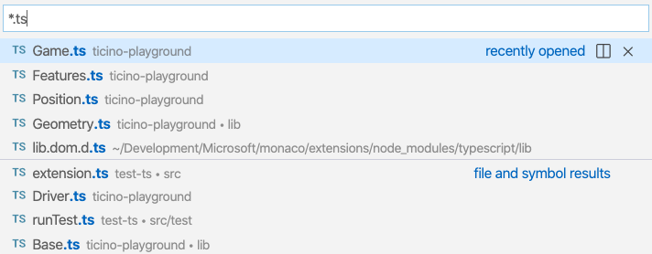

**Navigate from files to symbols**

You can now continue to navigate to the symbols of a file result simply by typing @. For the file that is currently selected, all symbols will appear and the editor will open in the background to reveal the active symbol. The video below also shows that you can group symbols by category by following @ with :.



**Filter results by separating multiple queries with spaces**

If you are getting too many results for a file search, you can add more search patterns after typing a space. For example, you can narrow down results by folder if you type <file name> <folder name> one after the other.



**Note:** This also works for the editor (Ctrl+Shift+O) and workspace (Ctrl+T) symbol picker. Any text after a space character will be used to filter by the container of that symbol.

**Input is preserved when switching providers**

If you leave Quick Open visible and switch to another provider (for example, from file search to symbol search), VS Code will apply whatever filter is typed and use it for the new provider. This allows you to quickly reuse the typed input for symbol search when it was previously used for a file search.

**Sort editor history by most recently used**

A new setting "search.quickOpen.history.filterSortOrder": "recency" allows you to sort editor history by the most recently opened items, even when starting to search. By default, editor history results will be sorted by relevance based on the filter pattern that was used.

**New command to open editor to the side**

A new command workbench.action.alternativeAcceptSelectedQuickOpenItem lets you add an additional keyboard shortcut to open files or symbols from Quick Open to the side. By default, Ctrl+Enter (macOS: Cmd+Enter) will open the file to the side in a new editor group, rather than in the current one.

**Reference $returnValue in Watch and Debug Console**

When it's available in the call stack, you can now reference a function's $returnValue in the Debug Console and Watch expressions.

